Week 5

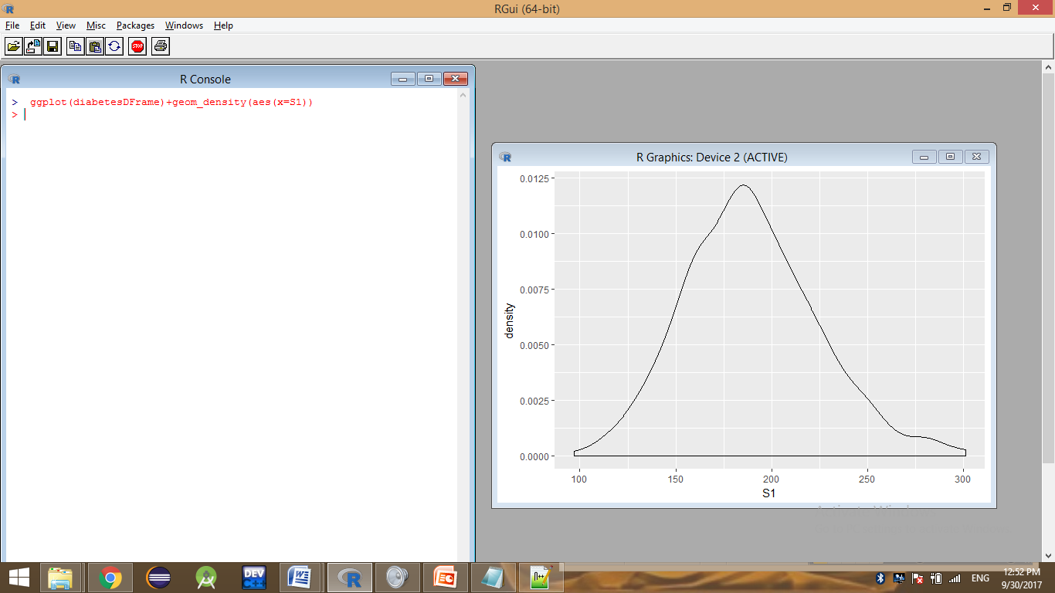

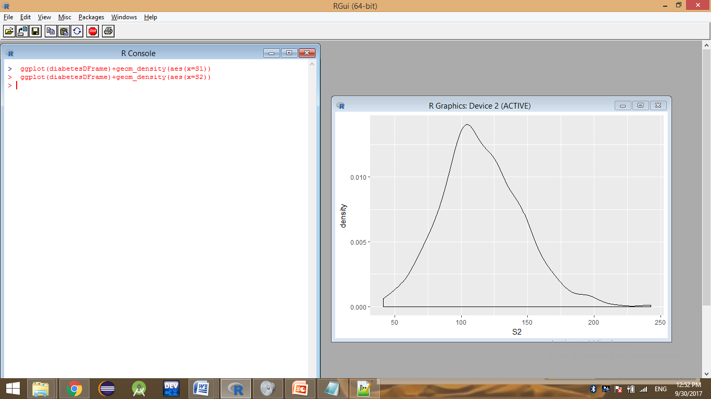

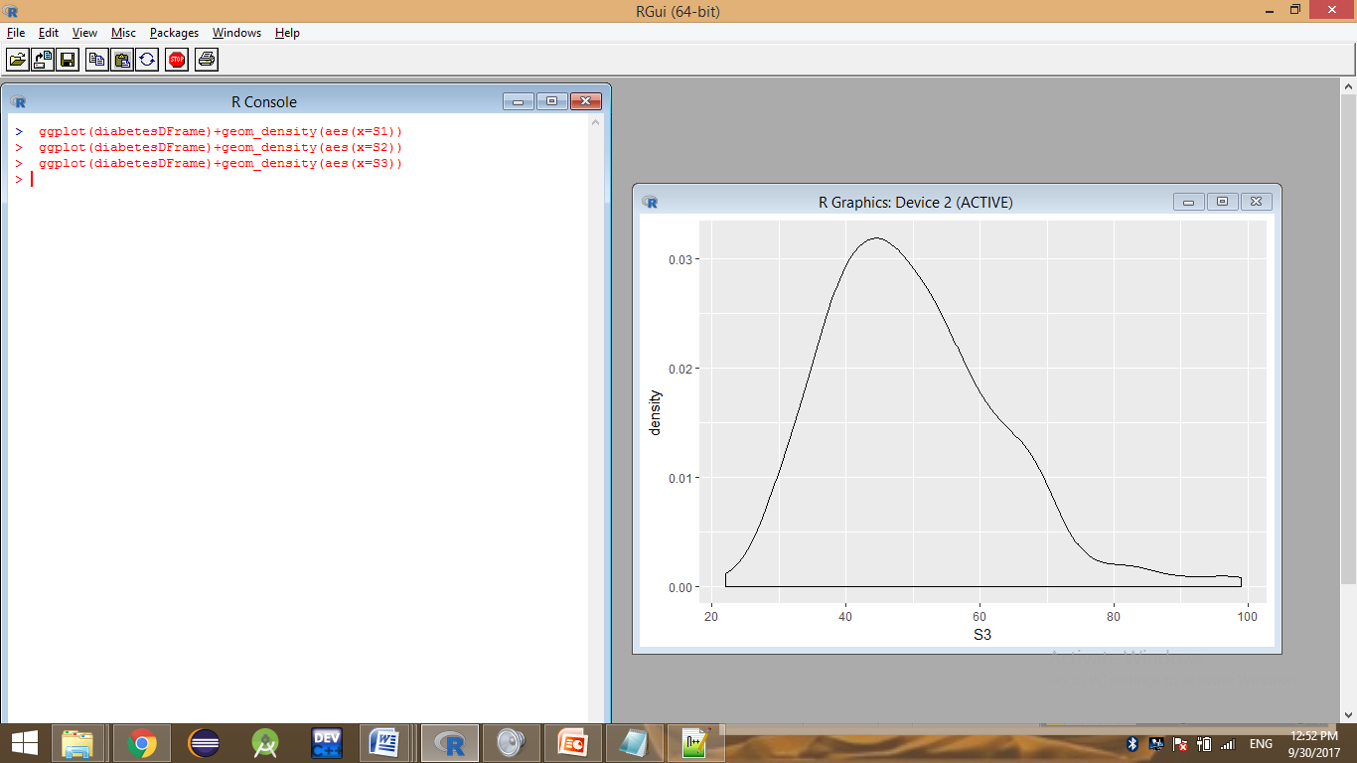

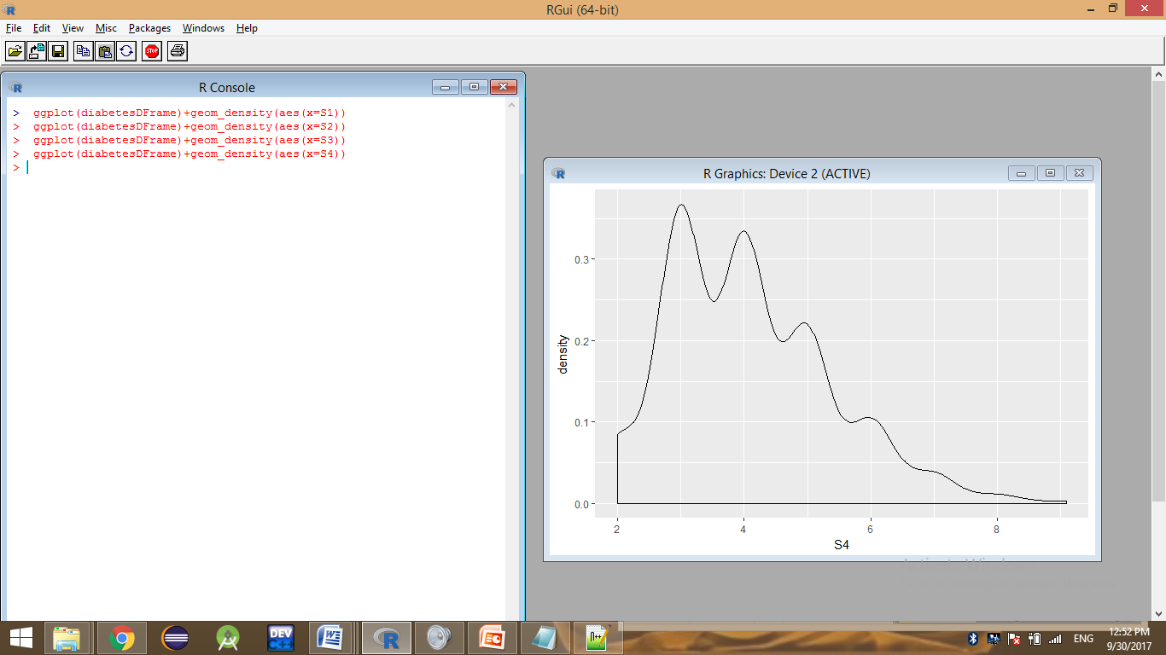

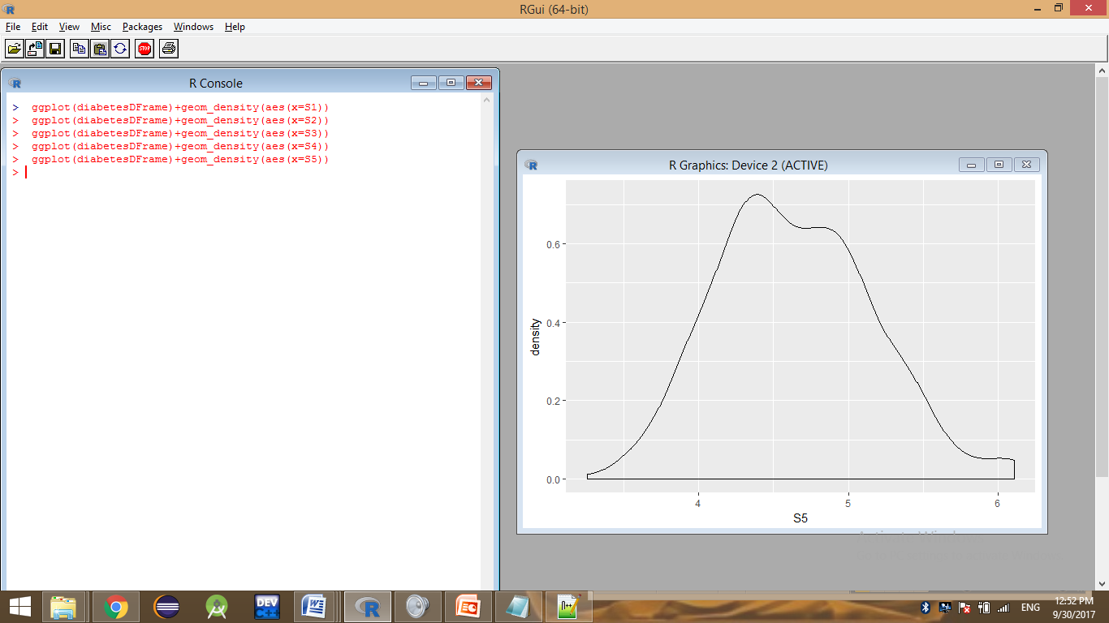

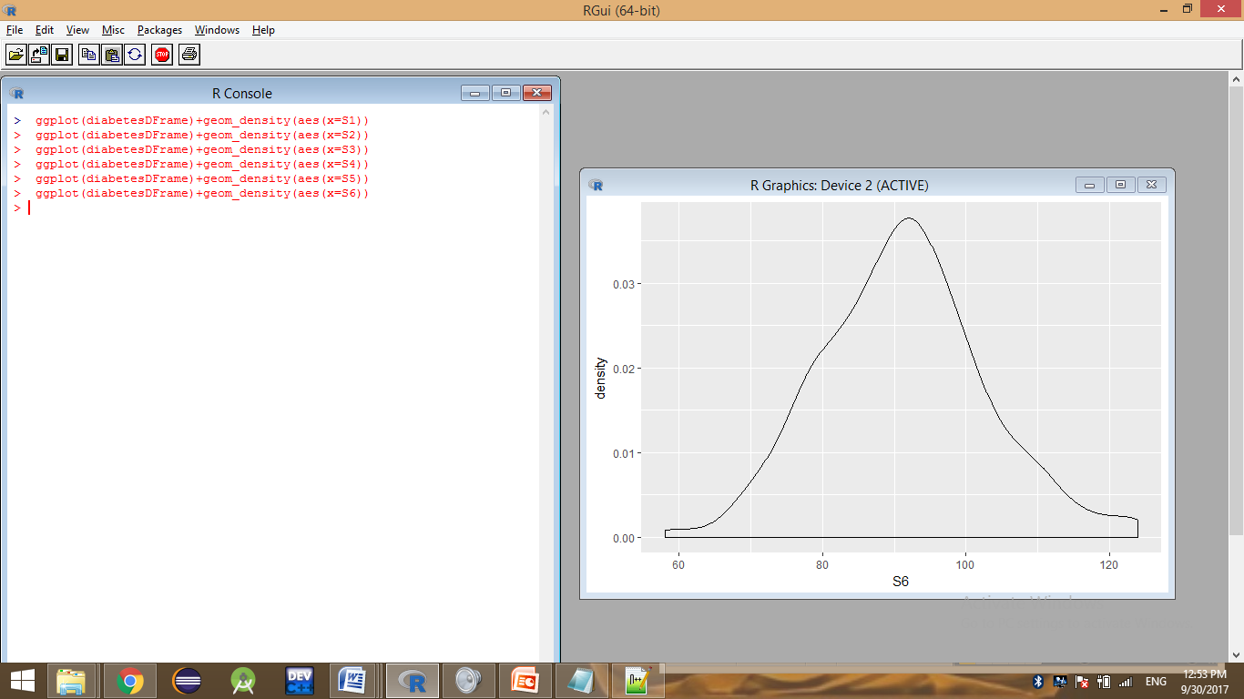

> names(diabetesDFrame)

[1] "AGE" "SEX" "BMI" "BP" "S1" "S2" "S3" "S4" "S5" "S6" "Y"

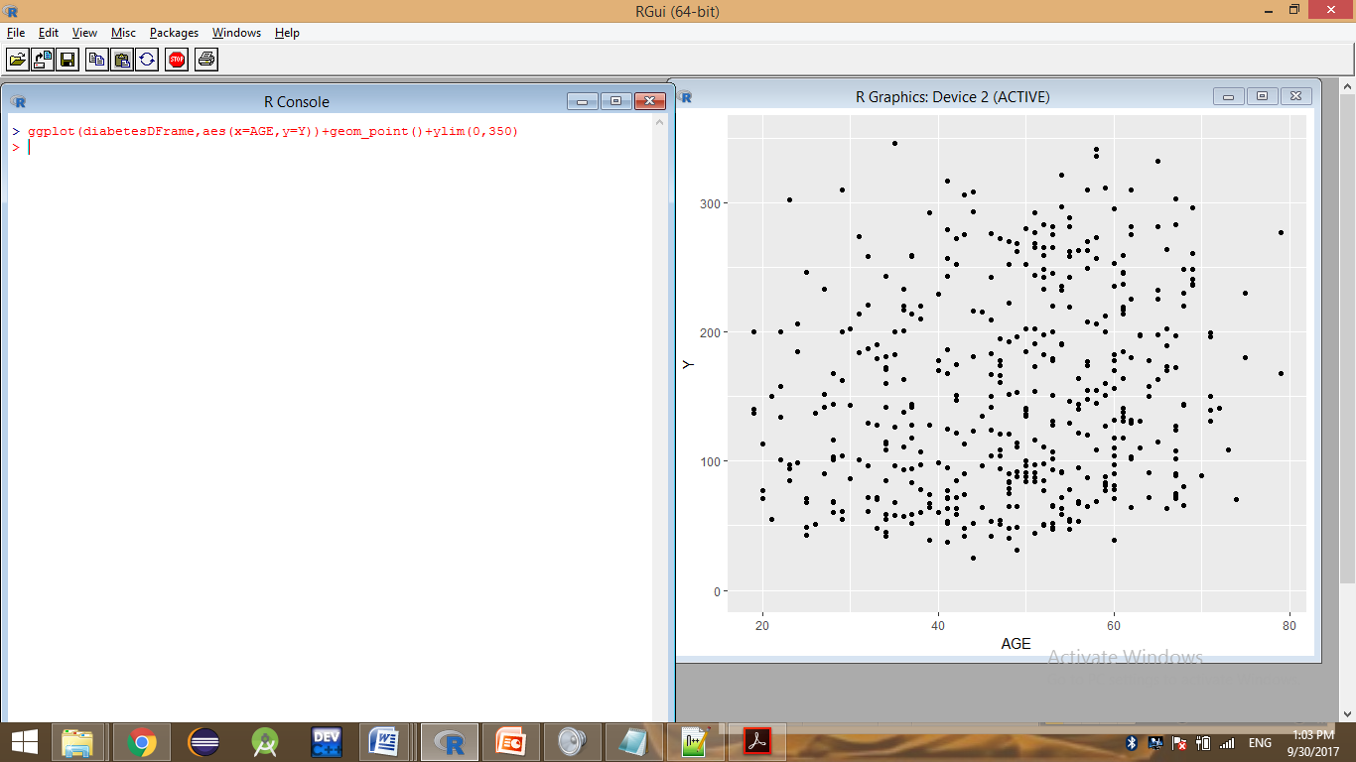

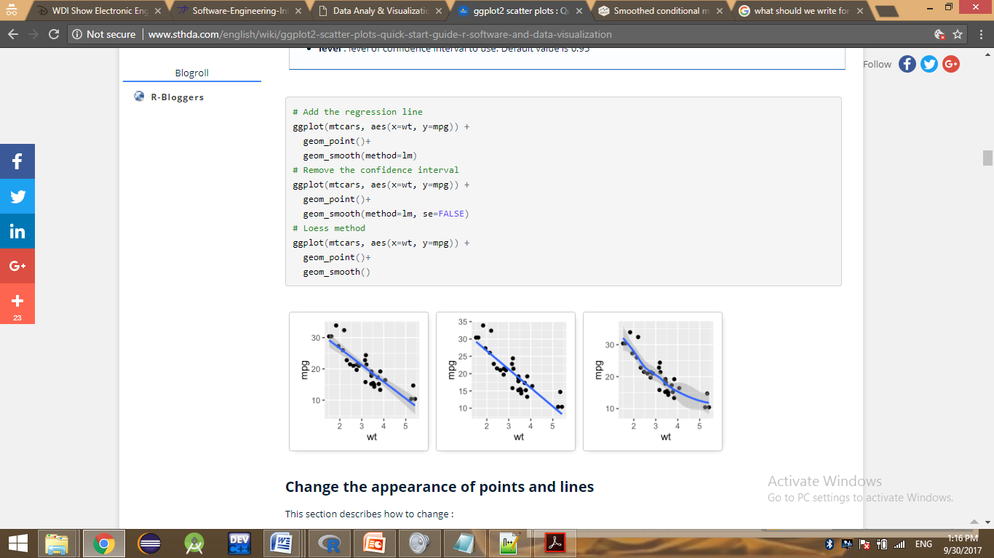

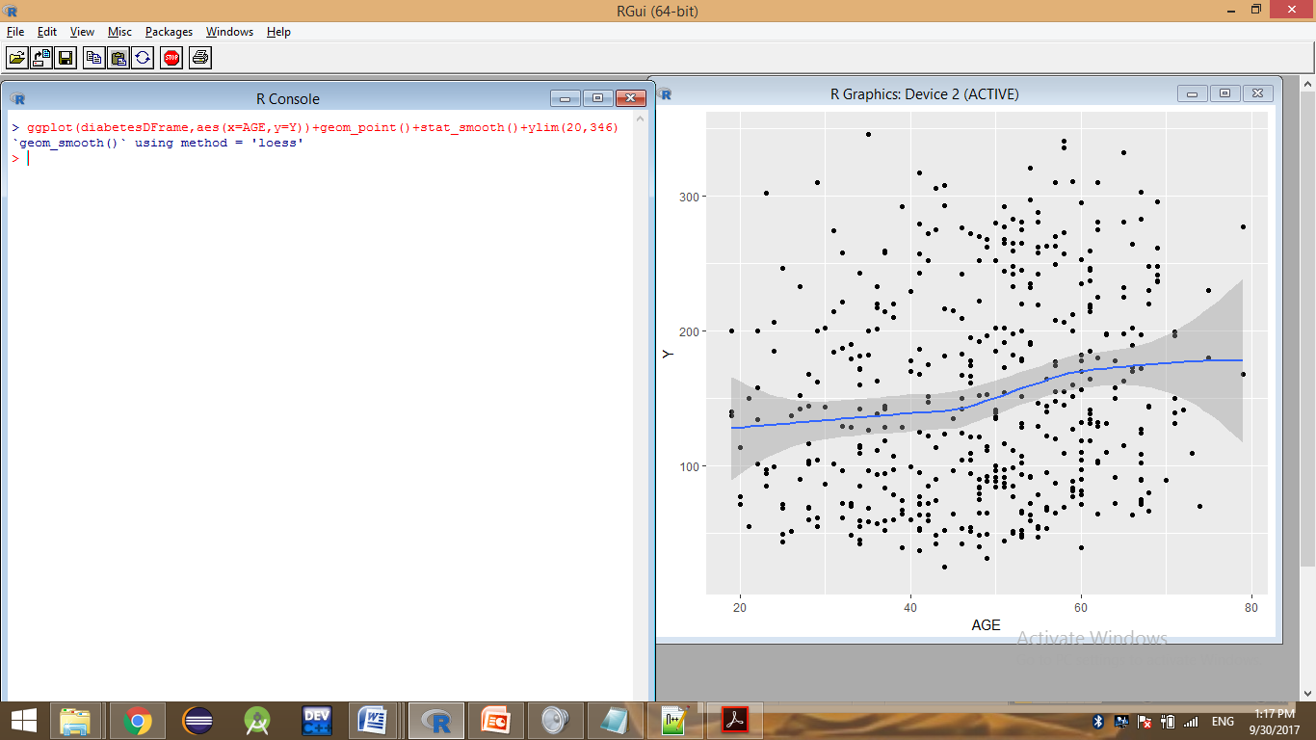

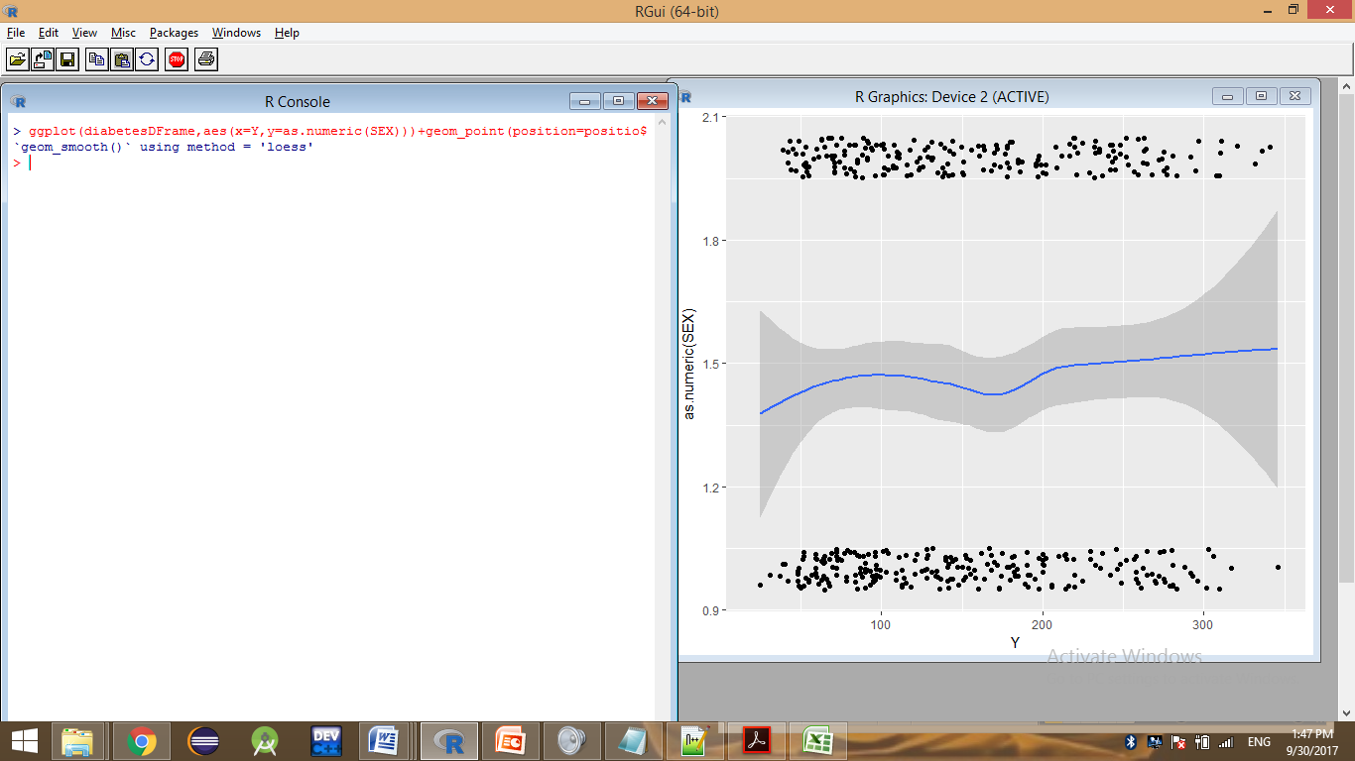

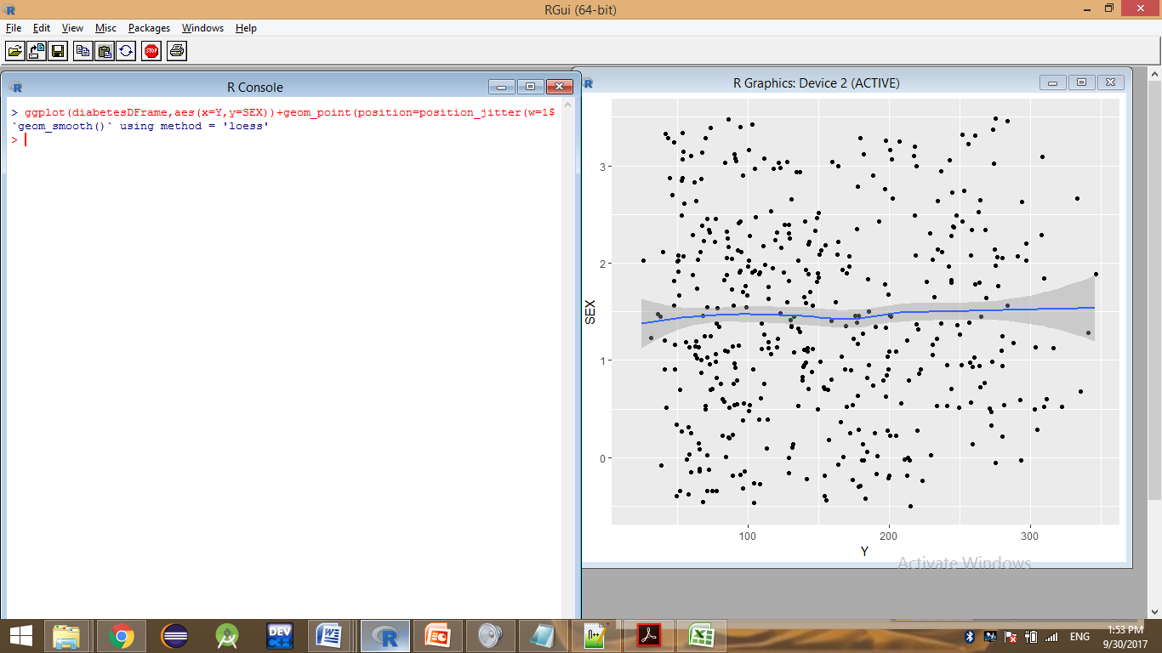

(diabetesDFrame,aes(x=Y,y=as.numeric(SEX)))+geom_point(position=position_jitter(w=0.05, h=0.05))+geom_smooth()

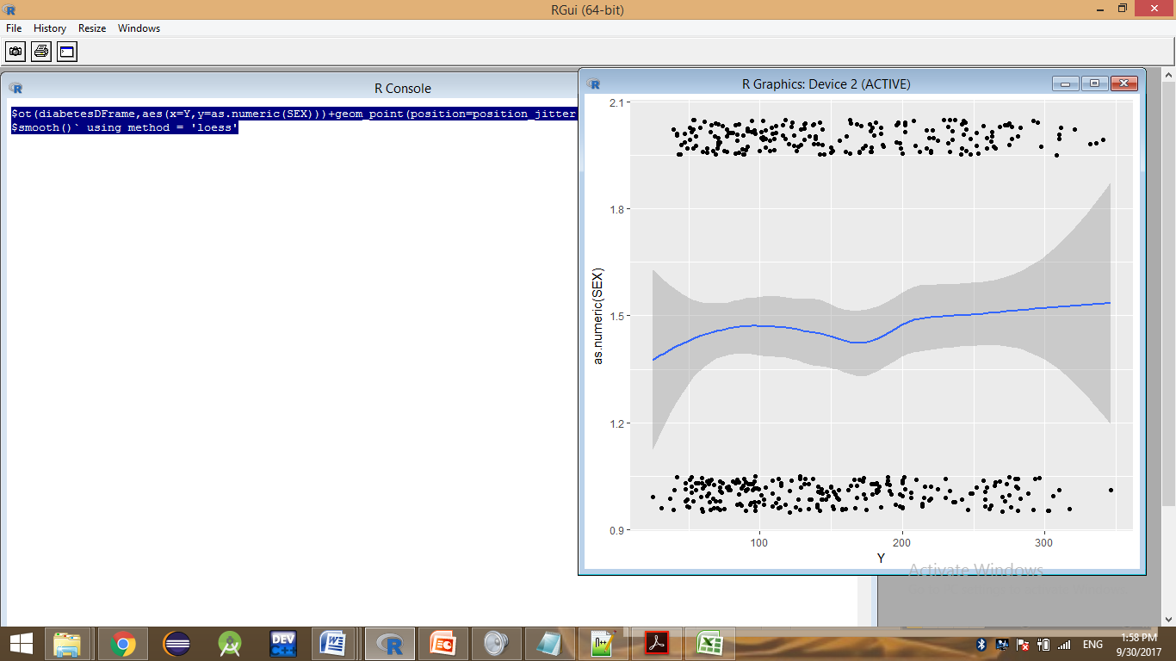

> ggplot(diabetesDFrame,aes(x=Y,y=SEX))+geom_point(position=position_jitter(w=0.05, h=0.05))+geom_smooth()

`geom_smooth()` using method = 'loess'

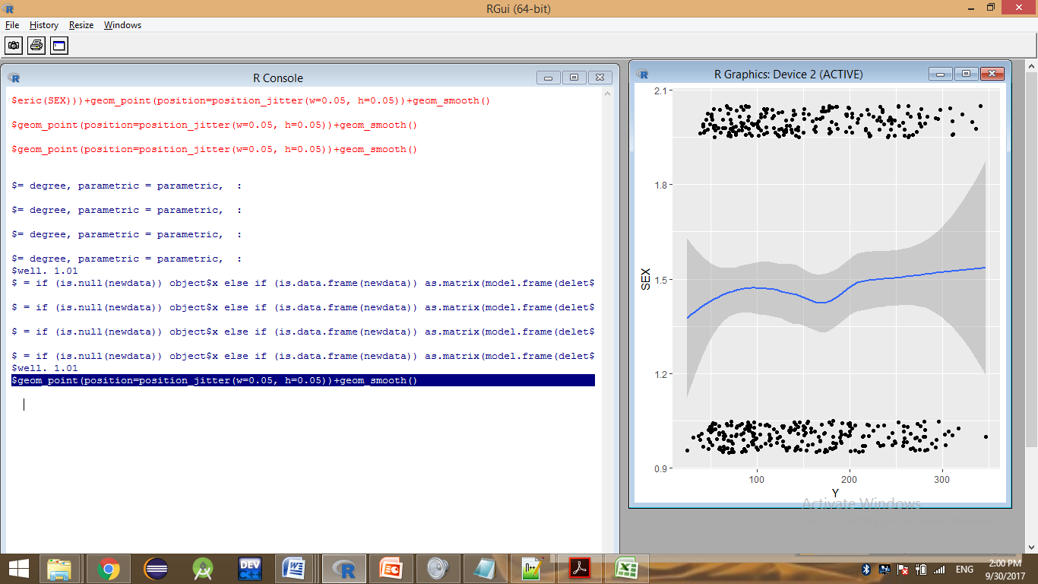

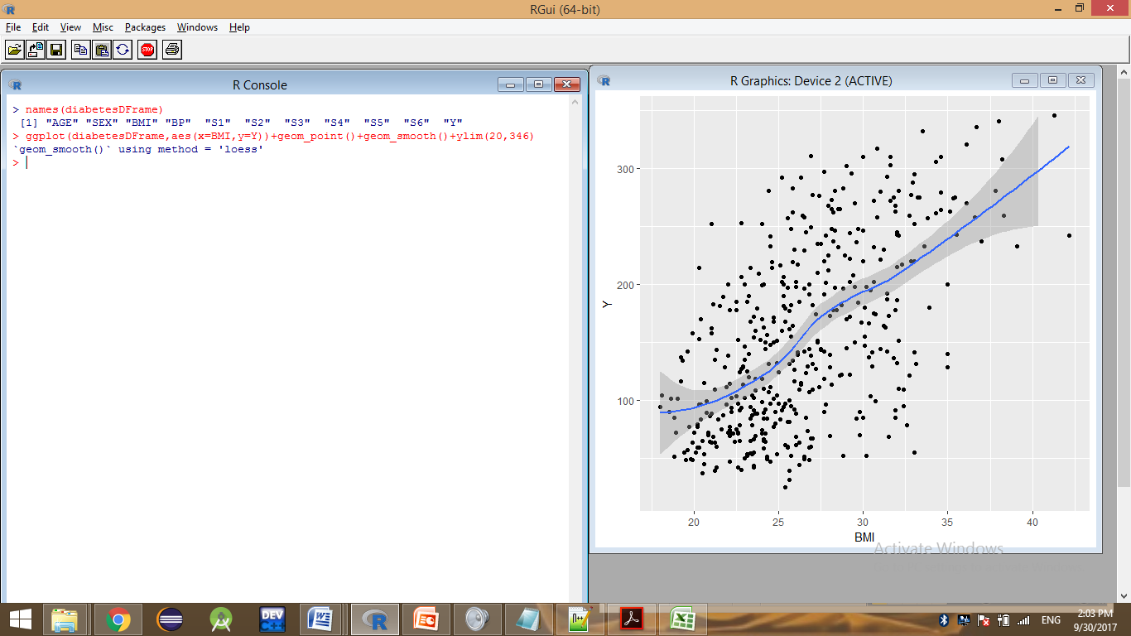

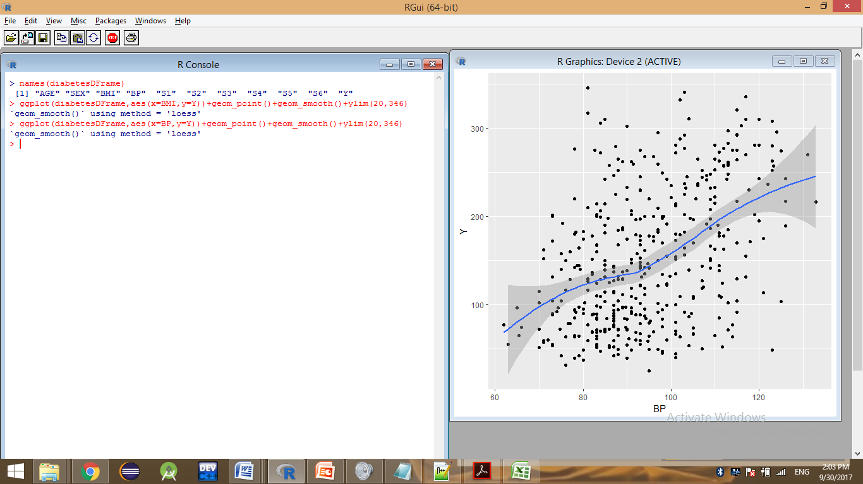

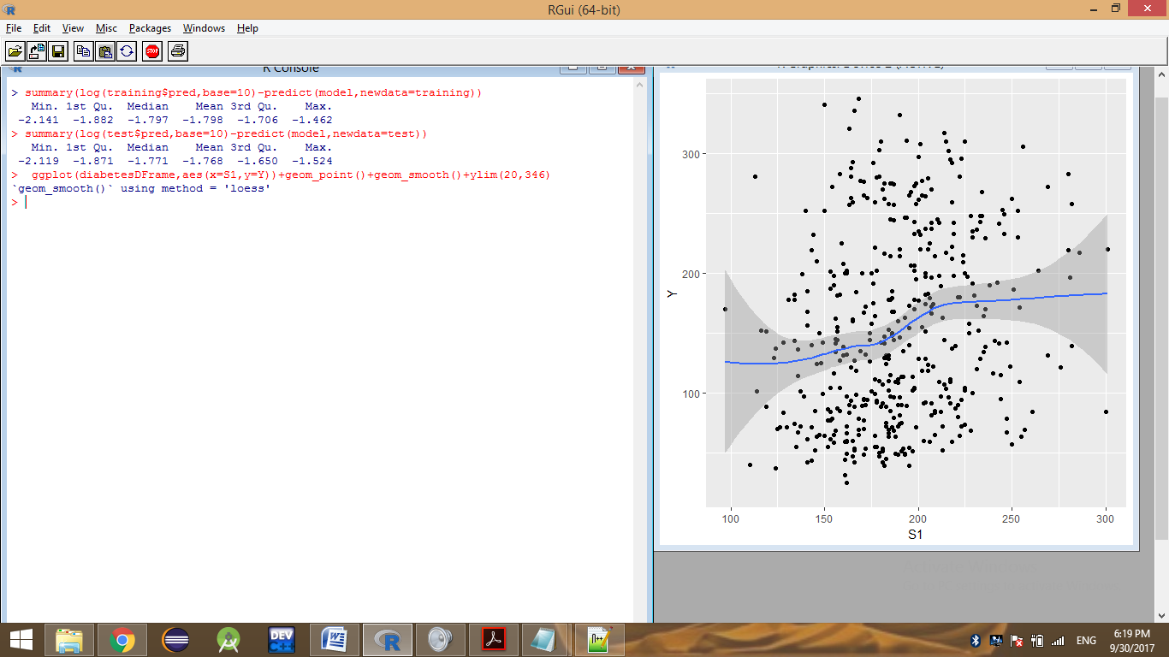

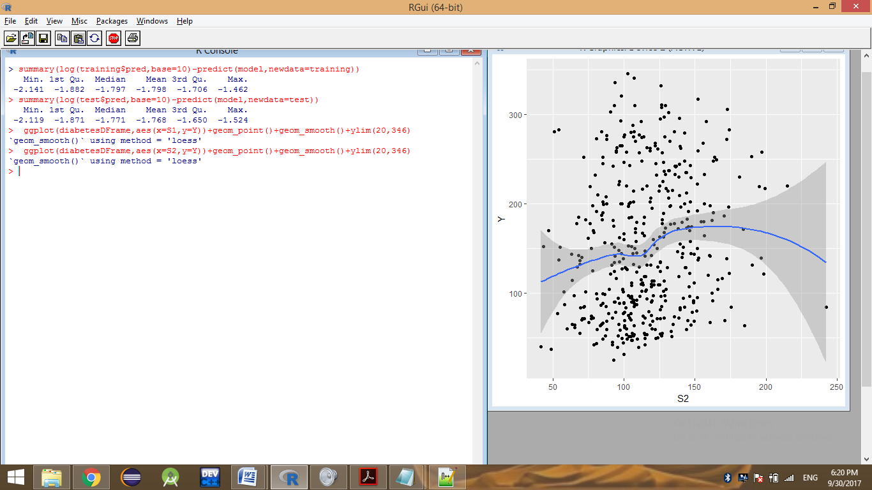

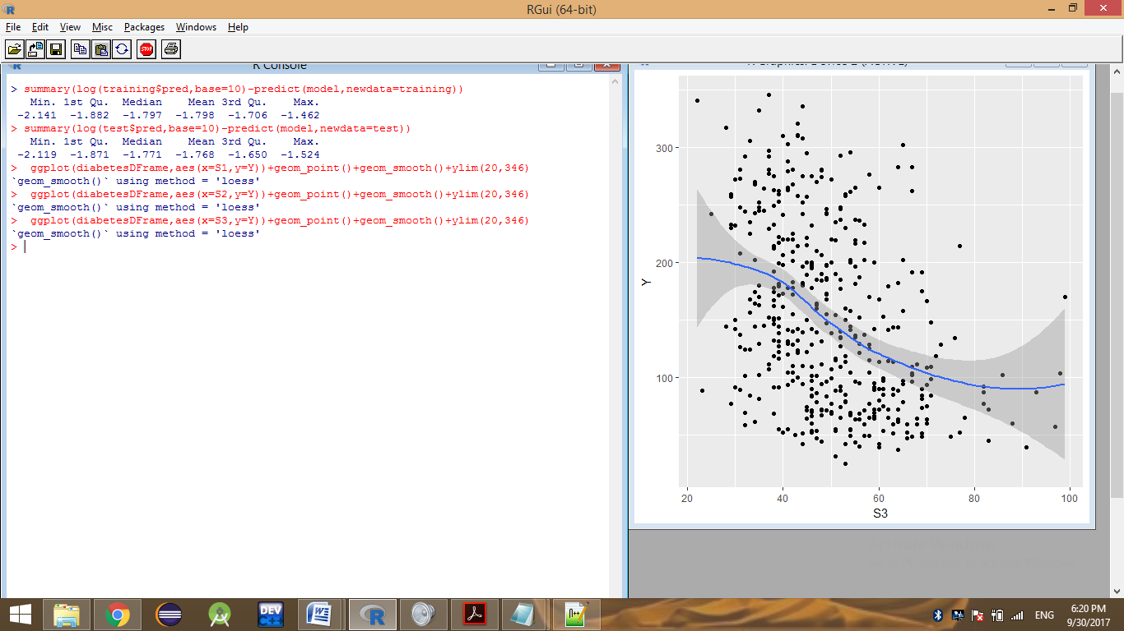

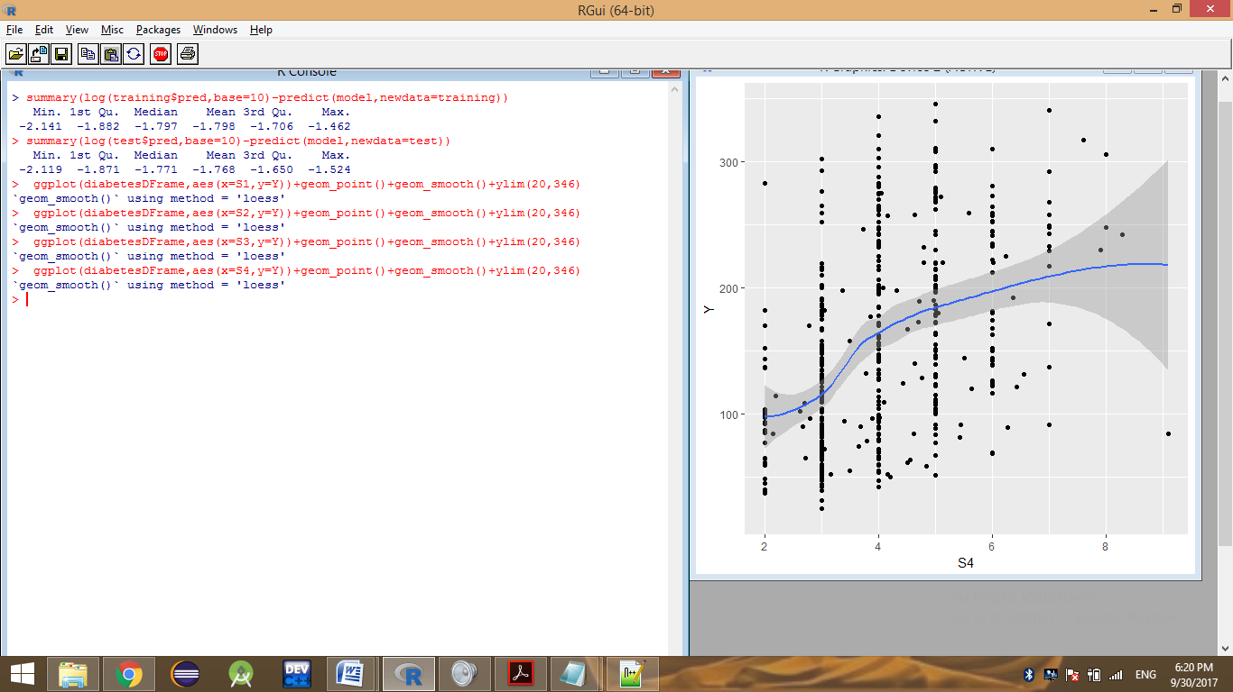

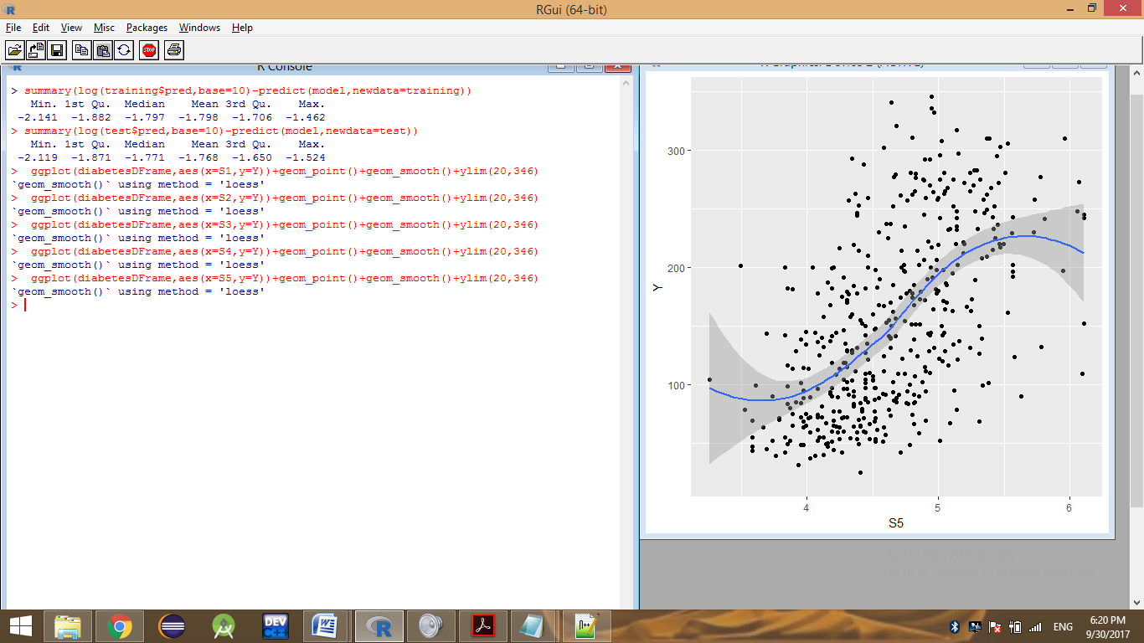

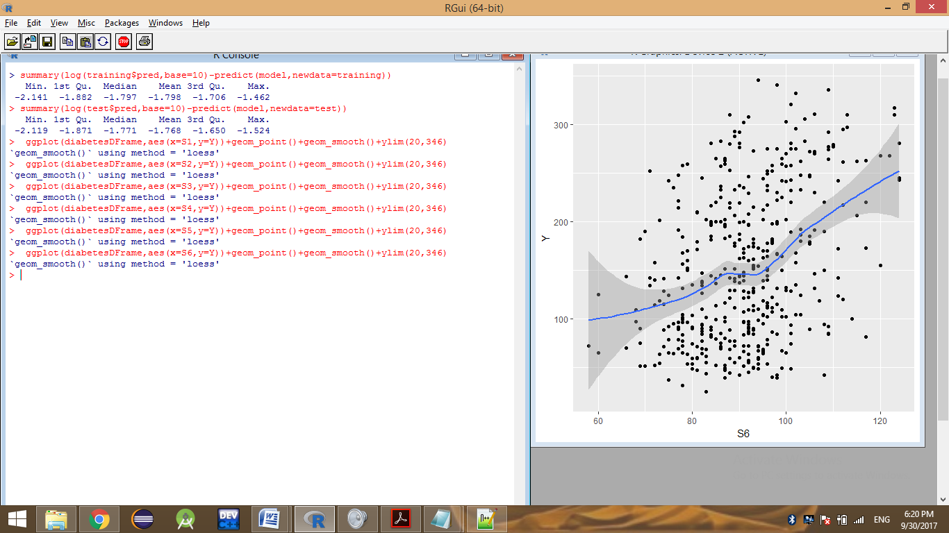

> ggplot(data=test,aes(x=pred,y=Y)) +

+ geom_point(alpha=0.2,color="black") +

+ geom_smooth(aes(x=pred,

+ y=Y),color="blue",linetype=2) +

+ geom_line(aes(x=Y,

+ y=Y),color="blue",linetype=2) +

+ scale_x_continuous(limits=c(0,320)) +

+ scale_y_continuous(limits=c(0,320))

